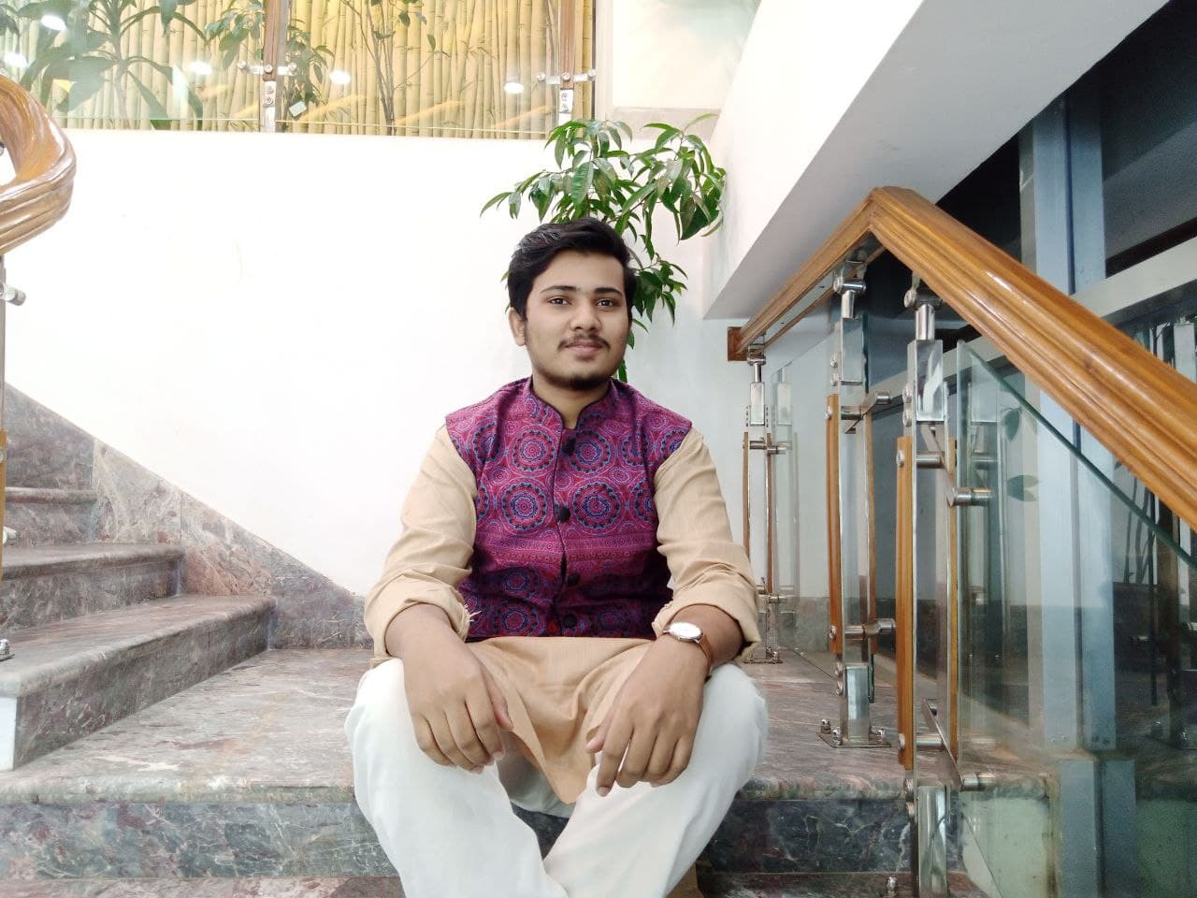**Tamjidul Islam**

Contact Phone: 01950084342

**Email:** [tamjidul.islam@northsouth.edu](mailto:tamjidul.islam@northsouth.edu)

**Student ID** :2121704642

**Department :** Electrical and Computer Engineering (ECE)

**Nationality :** Bangladeshi

**OBJECTIVE :**

I wish to apply for the position of in-charge in the ACM student chapter. I am a candidate who is deeply devoted to the club and is motivated to work sincerely with seniors. I believe this make me ideally suited for the job.

**Skill Highlights**

Proficient in using Word and PowerPoint and Xcel

Responsible, punctual, honest, adaptable, hard worker, leadership quality and sincere.

**Education**

BS|CSE| North South University (Currently Enrolled) ·

Credits completed: 48 · Current CGPA: 2.90

College | Milestone College

HSC:5.00

SSC: 5.00

**Language skill**

Bengali English Hindi